With an open mind, heart, and vagina, Time Out New York’s “LGBT Comedy Best Bet” Mindy Raf, demolishes the romantic comedy and the roles we play in it. In this critically acclaimed solo show, Raf demystifies love, loss, and sexuality, and engages her vulnerable, razor-sharp storytelling style to face the complexities of modern love and leave us asking, “could I ever do that?”
NOT THE ONE: a love story
Written and Performed by Mindy Raf
Directed by Tara Elliott

A hit among critics, anyone on the spectrum will not want to miss seeing Raf as what Theatre Is Easy calls “the kick-ass, real woman that you’ve been waiting for.”

More info can be found at: MindyRaf.com

CONTENTS
Press Release pg. 2
Creative Team pg. 3
Media Coverage pg. 4
Show History / Production Info pg. 5-6
Artist Statement/Audience Testimonials pg. 7
Script / Social Links / Contact Info pg. 8

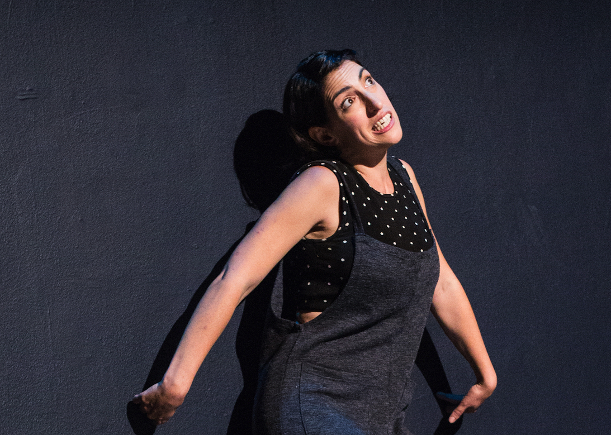

High-rez promo images available at http://bit.ly/MindyRafPromoHighRes

High-rez live on-stage images available at http://bit.ly/MindyRafLivePics

NOT THE One: a love story
Written and Performed by Mindy Raf
Directed by Tara Elliott
Cloud City, Williamsburg Brooklyn & The Tank, NYC (60 Mins)

“60 minutes of hilarity.” -Effort Lez

“★★★★★...prolific NYC Comedian...LGBT Best Bet” -Time Out New York

“…the kick-ass, real woman that you’ve been waiting for. Bravo.” Theatre Is Easy

“…a performance so intimate and in-the-moment that it almost feels as if she’s revealing
herself spontaneously…Raf is a star talent…highly recommended.” –Hy Reviews

"Raf had the audience in fits of laughter as she smoothly moved through her relatable and witty narrative."
-GO Magazine

Comedian Mindy Raf Performs Critically Acclaimed Edinburgh Fringe Solo Show For A Limited Run in NYC

After a successful 26 show run at the Edinburgh Fringe festival, Mindy Raf is bringing her solo show Not The One: a love story bak to NYC for a limited run at Cloud City on November 29 & 30th at 8PM and The Tank on December 6th 7:30 PM.

Raf takes complex conversations about coming out, modern love, loss, and sexuality and mixes them with some mansplaining and weed lube stories to deliver a highly compelling, satisfyingly provocative narrative.

Of the show, Raf says, “While the audience gets to laugh about my experiences regardless of how they identify or how they define love, my goal is to always be vulnerable on stage. I hope it encourages audience members to do the same whether on stage or off. We’re often taught in the gender binary that feelings and emotions make one look weak, to me that just couldn’t be further from the truth.”

Listing  Show: Not The One: a love story  Venue: Cloud City  Date: 11/29 & 11/30th  Time: 8:00 PM (60 min)  Tickets: $15  Web: MindyRaf.com | Media Contact  For further information/interview/review  Mia Gold  E: MGold@bil.nyc
NOTES TO EDITORS:
- New York based comedian Mindy Raf writes for television and is a published author.
- Mindy Raf has performed stand-up all over the US as well as authored a critically acclaimed young adult novel with Penguin.
- Raf writes for several websites and TV shows and connects to the LGBTQ+ community on subjects like anxiety, identity, visibility, polyamory, and finding your people.

###

CREATIVE TEAM

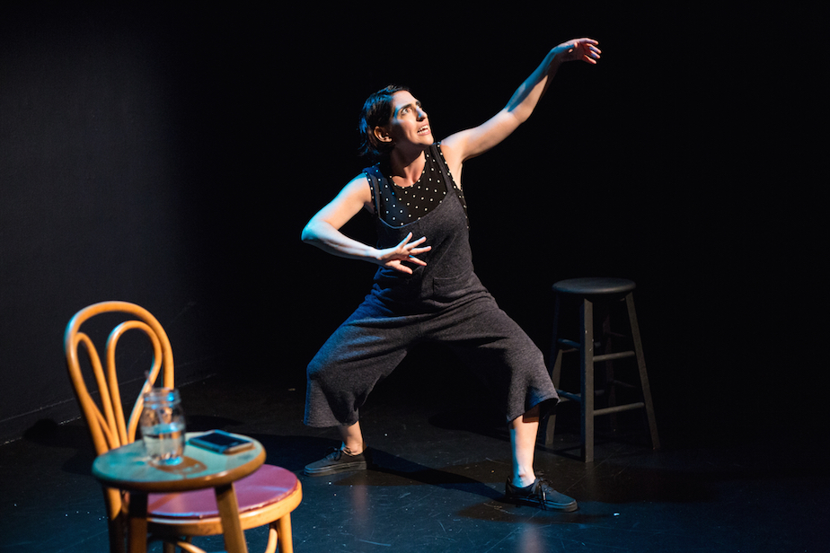

MINDY RAF (Writer/Performer)
NYC based artist Mindy Raf is an award winning published author, stand-up, and musical comedian. Raf has performed stand-up all over the USA with notable performances at the Women in Comedy Festival (Boston), NY Funny Songs Fest, SketchFest NYC, and Bridgetown Comedy Festival (Portland, OR). In New York, she performs regularly at The Peoples Improv Theatre, Dixon Place, QED, and Upright Citizens Brigade. In addition, Raf writes for several websites and TV shows including MTV’s Girl Code, VH1, College Humor, TNT, Lifetime, and was a contributor to the “My Parents Were Awesome” anthology (Random House). Raf’s young adult novel The Symptoms of My Insanity was published by Penguin Books. Publishers Weekly called Mindy’s writing “refreshing”. Web: mindyraf.com

TARA ELLIOTT (Director)
Tara Elliott directed the critically acclaimed one-woman show Burq Off! and is a producer of the Gotham Award winning web series Shugs & Fats. With a focus on developing new works, Tara has created and directed educational, community, and professional theater in Russia, Italy, France, Chile, Costa Rica, London, New York, and throughout the U.S. Tara has spent time living and making theater in Chile and fell in love with playwright Pablo Paredess’ prize winning Spanish language play Analfabetas which she translated and directed as Illiterates at the Robert Moss Theater. Web: TaraElliott.com

CIVIL DISOBEDIENCE (UK Producers)
All about art, Civil Disobedience loves managing great shows and helping talented performers reach new audiences. In addition to producing theatre, stand up, music, cabaret and performance art, they stage events with a creative twist and provide consultancy. With over 15 years of arts management and marketing experience, as well as in-depth knowledge of the international Fringe community, their book of contacts is second to none.
Web: wearecivildisobedience.com

PRESS/REVIEWS

★★★★ THE EDINBURGH REPORTER
"Barrier-breaking...inventive, sexually liberated (and liberating) one-woman show...cleverly conceived and engagingly kooky."

★★★★ ED FEST MAGAZINE
"... cheeky and infectious. ...intensely loveable, painfully relatable humour. And her dive into the romantic story of how she met her significant other is almost as moving as her powerful message about bisexuality.
"

THE SICK OF THE FRINGE
“Raf makes a bold case for understanding how we are always all of our identities, and how these identities intersect, inform, challenge and support each other in exciting ways...pointed and important revelations about the challenging and absurd realities of the American healthcare system, Midwestern Jewishness and family, and marginalized sexual identities. Raf challenges the idea that when we are dealing with one issue, or fighting one fight, we are not still engaged in a multitude of questions, oppressions, desires and conflicts. This confluence of influence is what makes [it] unique in its storytelling.”

WOMEN AROUND TOWN
"She’s all lovable neuroses, but a challenging and engaging storyteller. The people of Edinburgh are in for a treat."

THEATRE IS EASY
“Everyone has a million questions and opinions on modern romance, and Mindy Raf has a refreshing set of answers in her new solo show.

As a standup fan who has seen comics like Aziz Ansari, Hannibal Buress, and John Mulaney perform live sets, I was impressed by the high comedic bar Mindy Raf set for the night. She is refreshingly polished while still being the kick-ass, real woman that you’ve been waiting for. Bravo.

Finally someone is bringing humor and—most importantly —normality to parts of the human psychology and emotional life that are far too often romanticized, or even fetishized.”

NEW YORK TIMES
HIGHLIGHTED AS “COMEDY IN NYC THIS WEEK”
“modern love…sex, anxiety, coming out, polyamory, self-identity, queer culture and her relationship with the movie “Dirty Dancing.”

★★★★★ TIME OUT NEW YORK
“The stand-up queen of self deprecation . . .LGBT Best Bet.”

EFFORT-LEZ
"60 minutes of hilarity.”

HY REVIEWS
“In this one-woman show Raf achieves a whole new level of comedy greatness. Her script weaves a complex tapestry from her past relationships, anxieties, arcane bits of knowledge (e.g., she explains how the Dark Web can record you while you’re masturbating), and sexual preferences (which include being bi and polyamorous) that’s thoroughly compelling. At the same time, Raf delivers a performance so intimate and in-the-moment that it almost feels as if she’s revealing herself spontaneously.
Along similar lines, when anything unexpected happens (such as an audience member snapping fingers to a background song, or another audience member getting up and crossing the stage at a delicate moment to go to the bathroom), Raf is lightning-quick in providing a response so spot-on that it couldn’t have been better if she’d planned it.
With this show, Raf has developed into a star talent who demands attention. I highly recommend this wonderful production.

GO MAGAZINE
“In the midst of all of the terrifying political news out there, sometimes you just need to laugh it off. Mindy Raf brings audience members on a hilarious journey through life and death, polyamorous relationship struggles, anxiety, bisexuality, and sex positivity in her 60-minute performance.
As a queer woman going to comedy shows in NYC can be risky. You never know if you’re going to hear misogynistic comments, rape jokes or homophobic slurs coming from the stage. “Keeping My Kidneys” was different; Raf used her intersecting identities as a Jewish, bi/pansexual, polyamorous woman to bring the audience together in similar lived experiences like awkward texting, office romances, and nerve-wracking anxiety. Raf had the audience in fits of laughter as she smoothly moved through her relatable and witty narrative of trying to figure it all out.”

SHOW HISTORY
Fall '16
NYC Premiere Production Run, PIT Loft

Winter/Spring ‘17
Monthly Run PIT Loft (3 months) (SOLD OUT)

Spring ’17
Headlining Show at Hacienda Studio, Curious Fox Presents (SOLD OUT)

Summer ‘17
59E59 Theater East To Edinburgh Festival (SOLD OUT- 2 night run)

2017 Edinburgh Fringe Festival, Gilded Balloon-Rose Theatre–Attic (Aug 2-28)

Fall ‘17
Consider This, A Day of Challenging Status Quo in Sex & Relationships at the
House of Yes (Headlining Act)

Fall ‘17
Cloud City

Winter ‘18
The Tank

PRODUCTION

NOT THE ONE is designed to run with minimal set, light & sound cues.

Set
The current production can run with any combo of three (chairs, stools, blocks).

Lights/Sound
The current production only requires pre-show music and 5 lighting cues. Show can also run effectively in spaces sans sound and light. No handheld mic is used in show. For venue size larger than 60, a wireless or floor mic is required.

Full show
NOT THE ONE: 60 min

Preview Version
NOT THE ONE: 20 min
This teaser preview can be done with
hand-held mic in stand-up comedy clubs spaces as well.

ARTIST STATEMENT

NOT THE ONE: a love story is a deeply personal show, and so important to me. I look at the show not only as entertainment but a wonderful opportunity to create an international conversation through comedy and storytelling about how we're taught to define love and ourselves through our relationships.

Much coverage of open relationships is narrow in scope and fails to accurately represent ethical non-monogamy. There is also a lack of lesbian, bisexual, pansexual, queer, or trans identity represented in these stories. When we represent and tell our own stories we can break the barriers that stand in the way of normalizing what others see as unconventional. I’m proud to say that NOT THE ONE is creating a platform for this representation, and stirring up this important conversation.
-Mindy Raf

AUDIENCE TESTIMONIALS

"I saw the show with my husband. We absolutely loved it. Mindy is so funny and has an incredible presence. The show is hilarious and personal and vulnerable and entertaining. I laughed the entire time. Which is rare (especially these days). “
-Deya Drake

**
"I cried with laughter. Additionally though, thank you for being so open about your sexuality and polyamory! It's beautiful and amazing. It made me feel more comfortable with myself and my own preferences"
-Chloe

**
"I saw Mindy's show the first time with a friend and cousin and knew I wanted to relive the experience and bring more friends who would love it just as much. Seeing it a second time was even better than the first. Even though my romantic and parental relationships look different than Mindy's, she somehow reveals her specific experiences as universal-and in the most hilarious way. She’s simply a great storyteller.”
-Candice Ammori

**
"I'm still thinking about Keeping My Kidneys, days after seeing...it was so funny and well-written and honest and real, and left me with this feeling of resolved incompleteness that the best poems do - thrown back out into the world, not knowing how it all is going to unfold, and somehow being okay with that…"
Josh Lefkowitz, Author/Poet

**
"So funny and really moving. Coming again, and I'm bringing friends."
Mandy Evans Brown, Producer/Actress

**
“I laughed and cried and laughed and cringed and laughed more, cried a little and then laughed and then it ended. And I was ready to see it again- for the 4the time.”
Effy Blue, Relationship Coach/Speaker

SCRIPT PULL QUOTES
PDF copy of script available, please send request to MindyRaf@gmail.com

**

SOCIAL MEDIA LINKS

Instagram
http://instagram.com/mmmindela

Twitter
http://twitter.com/mindyraf

Facebook
http://facebook.com/mindyrafcomedy

High-rez promo images
http://bit.ly/MindyRafPromoHighRes

High-rez live on-stage images
http://bit.ly/MindyRafLivePics

**

CONTACT INFO

Writer/Performer, Mindy Raf
MindyRaf@gmail.com

Director,Tara Elliott
Tara.Cristina@gmail.com

2017 UK/Edinburgh Fringe Festival Producers, Civil Disobedience Productions
Barry Church-Woods, Josef Church-Woods, Louise Oliver
wearecivil@outlook.com

Publicity/Media Contact/NYC Booking Contact
Mia Gold
MGold@bil.nyc

Bookings: Colleges, Talkbacks, Guest Speaker
Antonia@MBRCreative.com

MINDYRAF.com

